**Practice_18_2**

**(Nested Dictionary)**



**1 saýlananda**

**Output:**

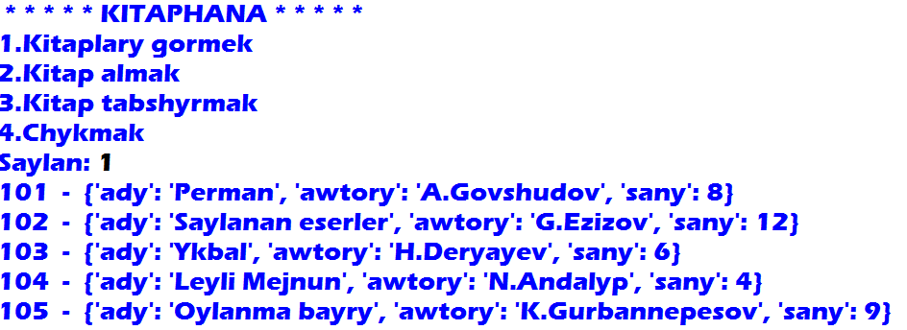

**2 saýlananda**

**Output:**

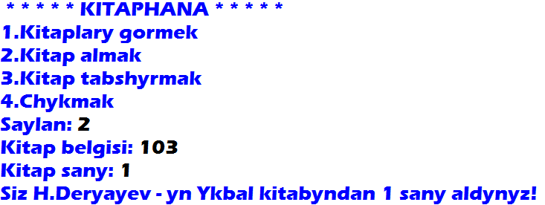

**3 saýlananda**

**Output:**

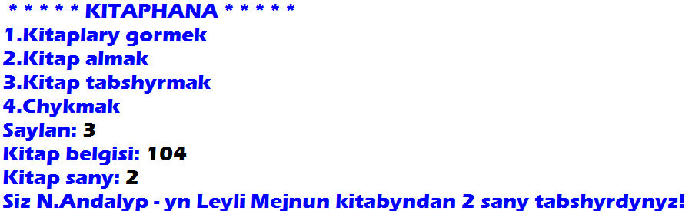

**4 saýlananda**

**Output:**

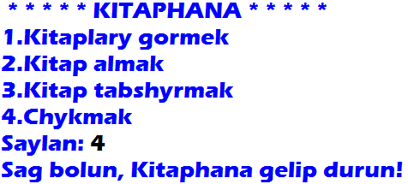

**Başga sanlar saýlananda**

**Output:**

